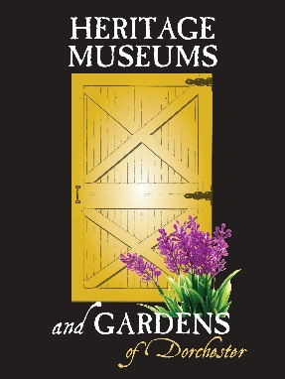

Dorchester County Historical Society
2022

With YOUR support, we can do so much more.

Name____________________________________________________________________________

Mailing Address____________________________________________________________________

____________________________________________________________________________________

Phone Number______________________________Email___________________________________

_______Email my newsletter _______Contact me about volunteering
Membership Level
_____Student $5 _____Family $60
_____Individual $35 _____Benefactor – NARM $100**

You May Now Join & Renew Your Membership Online!
www.dorchesterhistory.org

**This association gains you access to over 1,000 institutions across North America.
Dorchester County Historical Society
1003 Greenway Drive Cambridge, Maryland 21613
410.228.7953 dchs@verizon.net www.dorchesterhistory.org
Staff Use

EXCEL _____
EMAIL _____
LET/CARD _____
ELECT. N/L _____
VOLUNTEER _____

